# The Creation of a National Air Force

Second in a projected 4-volume series on the history of the Royal Canadian Air Force (RCAF). The 4 volumes cover the RCAF from before its start on April 1, 1924. They continue until it was absorbed into the tri-service Canadian Armed Forces on February 1, 1968. This volume is about how the RCAF became a national institution.

[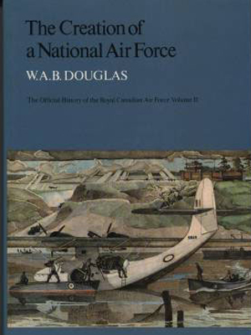](https://www.canada.ca/content/dam/themes/defence/caf/militaryhistory/dhh/popular/creation-national-air-force-1.pdf)

**The Creation of a National Air Force: The Official History of The Royal Canadian Air Force, Volume II**

* [Pages 1 to 133](https://www.canada.ca/content/dam/themes/defence/caf/militaryhistory/dhh/popular/creation-national-air-force-1.pdf); PDF version, 9 MB
* [Pages 134 to 278](https://www.canada.ca/content/dam/themes/defence/caf/militaryhistory/dhh/popular/creation-national-air-force-2.pdf); PDF version, 9 MB
* [Pages 279 to 425](https://www.canada.ca/content/dam/themes/defence/caf/militaryhistory/dhh/popular/creation-national-air-force-3.pdf); PDF version, 9 MB
* [Pages 426 to 577](https://www.canada.ca/content/dam/themes/defence/caf/militaryhistory/dhh/popular/creation-national-air-force-4.pdf); PDF version, 9 MB
* [Pages 578 to 743](https://www.canada.ca/content/dam/themes/defence/caf/militaryhistory/dhh/popular/creation-national-air-force-5.pdf); PDF version, 9 MB
* [Pages 744 to 797](https://www.canada.ca/content/dam/themes/defence/caf/militaryhistory/dhh/popular/creation-national-air-force-6.pdf); PDF version, 2.9 MB
* Date of publication: 1986
* ISBN: 0-8020-2584-6
* Publisher: University of Toronto Press
* Author: Douglas, W.A.B.